**NAME K.GOKUL**

**REG NO 192111038**

**DAY -1 PROGRAMMAS**

1.Write a java program to print “helloworld”.

Program:-

class hloworld  
{  
 public static void main(String[] args)  
 {  
 System.*out*.println("hello world");  
 int a=10,b=20,c;  
 c=a+b;  
 System.*out*.println("output:"+c);  
  
 }  
}

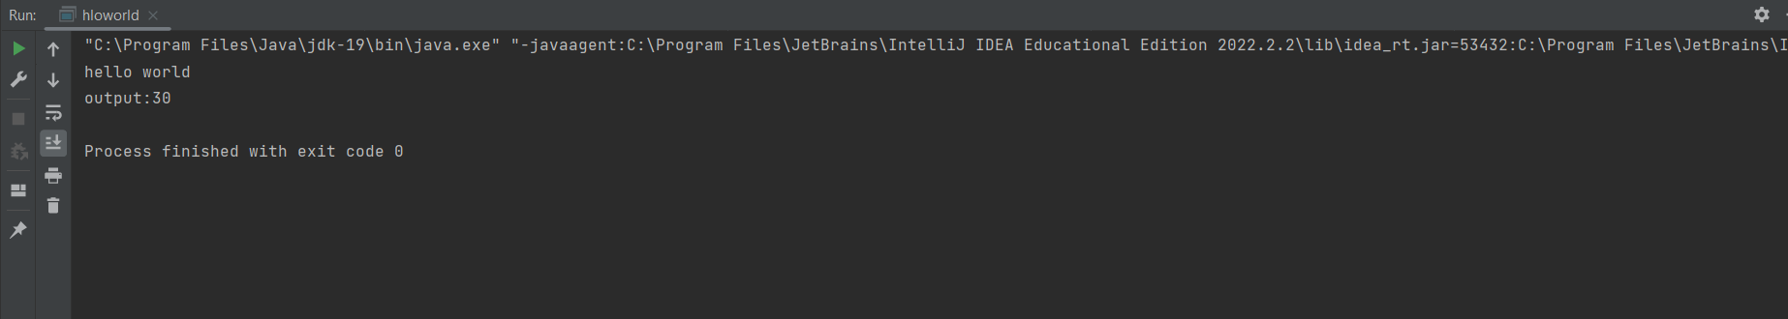

2.Write a java program to find simple interest.

Program:-

class si  
{  
 public static void main(String[] args)  
 {  
 double p = 100000, t = 3, r = 3.5, si;  
 si = (p * t * r) / 100;  
 System.*out*.println("simple intrest:" + si);  
 }  
}



3.Write a java program to read input from user to perform addition of two numbers.

Program:-

import java.util.*;  
class twad {  
 public static void main(String args[])  
 {  
 int a, b, c;  
 Scanner s = new Scanner(System.*in*);  
 System.*out*.println("enter the two numbers:");  
 a=s.nextInt();  
 b=s.nextInt();  
 c=a+b;  
 System.*out*.println("output:"+c);  
 }  
}

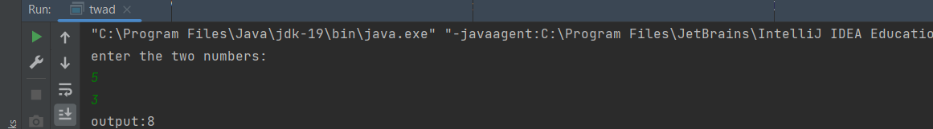

4.Implement a java program to convert celcius to Fahrenheit.

Program:- class temp  
{  
 public static void main(String args[])  
 {  
 float f,c;  
 c=13;  
 f=((c*9)/5)+32;  
 System.*out*.println("tempertaure after conerting into fahrenheat:"+f);  
 }  
  
}



5.Implement a java program to check whether a number is odd or even.

Program:- import java.util.*;  
public class odeve  
{  
 public static void main(String args[])  
 {  
 Scanner s = new Scanner(System.*in*);  
 int a;  
 System.*out*.println("Enter any Number:");  
 a = s.nextInt();  
 if (a % 2 == 0)  
 {  
 System.*out*.println(a + " is Even");  
 } else  
 {  
 System.*out*.println(a + " is Odd");  
 }  
 }  
}

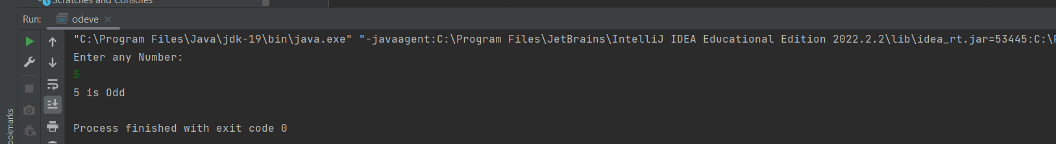

6.Implement a java program to check leap year or not.

Program:-

import java.util.*;  
class leap  
{  
 public static void main(String args[])  
 {  
 Scanner s = new Scanner(System.*in*);  
 int y;  
 System.*out*.println("Enter any Year:");  
 y = s.nextInt();  
 if (y % 4 == 0 && (y % 100 != 0 || y % 400 == 0))  
 {  
 System.*out*.println(y + " Is Leap Year");  
 } else  
 {  
 System.*out*.println(y + " Is not a Leap Year");  
 }  
 }  
}

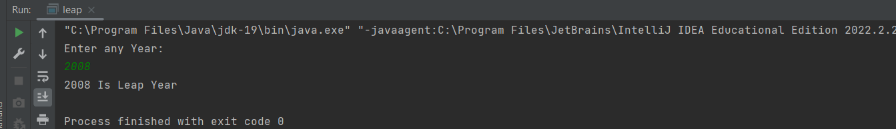

7.Implement a java program to check eligibility of a person to vote.

Program:-

import java.util.*;  
class vote  
{  
 public static void main(String args[])  
 {  
 Scanner s=new Scanner(System .*in*);  
 int y;  
 System.*out*.println("Enter Age of a person:");  
 y=s.nextInt();  
 if(y>=18)  
 {  
 System.*out*.println("Person is Elegible to Vote");  
 }  
 else  
 {  
 System.*out*.println("Person is Not elegible to vote");  
 }  
 }  
}

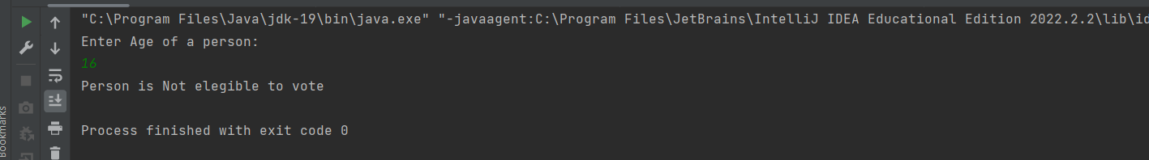

8.Write a java program to check whether the number is positive or negative or zero.

Program:-

import java.util.*;  
class posneg  
{  
 public static void main(String args[])  
 {  
 Scanner s=new Scanner(System .*in*);  
 int y;  
 System.*out*.println("Enter number to check:");  
 y=s.nextInt();  
 if(y<0)  
 {  
 System.*out*.println("niumber is negative");  
 }  
 else if (y==0)  
 {  
 System.*out*.println("number is a zero");  
 }  
 else  
 {  
 System.*out*.println("niumber is positive");  
  
 }  
 }  
}

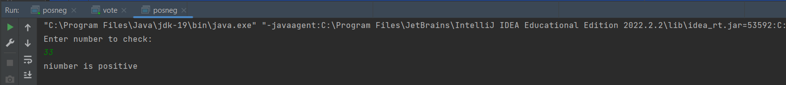

9.Write a program to perform sum of a ‘n’ numbers.

Program:-

import java.util.*;  
class SumOfSeries  
{  
 public static void main(String[] args)  
 {  
 int n,i,sum=0;  
 Scanner s=new Scanner(System.*in*);  
 System.*out*.println("enter the number to print sum upto:");  
 n=s.nextInt();  
 for(i=0;i<=n;i++)  
 {  
 sum=sum+i;  
 }  
 System.*out*.println("sum upto enterd number is:"+sum);  
 }  
}

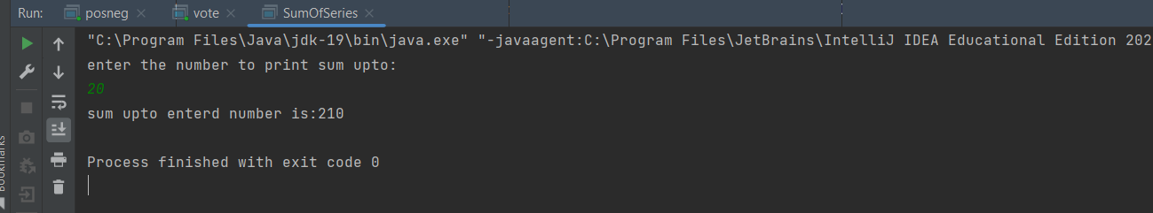

10.Write a java program to find factorial of a number.

Program:-

import java.util.*;  
class fact  
{  
 public static void main(String[] args)  
 {  
 int n,i,fact=1;  
 Scanner s=new Scanner(System.*in*);  
 System.*out*.println("enter the number:");  
 n=s.nextInt();  
 for(i=1;i<=n;i++)  
 {  
 fact=fact*i;  
 }  
 System.*out*.println("fact of number is:"+fact);  
 }  
}

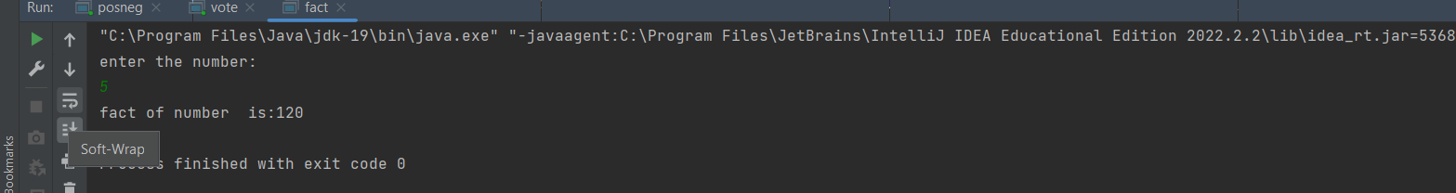

11.Write a java program to print Fibonacci series.

Program:-

import java.util.*;  
class fibonacci  
{  
 public static void main(String[] args)  
 {  
 int a=0,b=1,c,i,n;  
 Scanner s=new Scanner(System.*in*);  
 System.*out*.println("enter the number");  
 n=s.nextInt();  
 System.*out*.println("The fibonacci series is:");  
 System.*out*.println(a+"\n"+b);  
 for(i=2;i<=n;i++)  
 {  
 c=a+b;  
 System.*out*.println(c);  
 a=b;  
 b=c;  
 }  
 }  
}

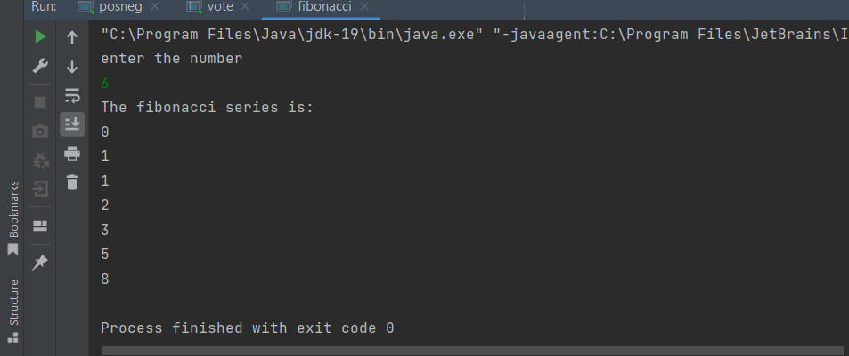

12.Write a java program to check whether a number is prime or not.

Program:-

import java.util.*;  
class prime  
{  
 public static void main(String[] args)  
 {  
 int n,i,count=0;  
 Scanner s=new Scanner(System.*in*);  
 System.*out*.println("enter the numbe:");  
 n=s.nextInt();  
 if (n == 0 || n == 1)  
 count = 1;  
 for(i=2;i<n;i++)  
 {  
 if(n%i==0)  
 {  
 count++;  
 }  
 }  
 if(count==0)  
 {  
 System.*out*.println(n+"\t is a prime number");  
 }  
 else {  
 System.*out*.println(n+"\t is not a prime number");  
  
 }  
 }  
}

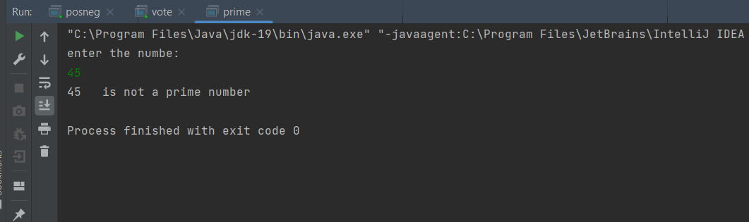

13.Write a java program to check whether a number is Armstrong or not.

Program:-

import java.util.*;  
class armstrong  
{  
 public static void main(String[] args)  
 {  
 int num,r,sum=0,temp;  
 Scanner s=new Scanner(System.*in*);  
 System.*out*.println("enter the number:");  
 num=s.nextInt();  
 temp=num;  
 while (num>0)  
 {  
 r=num%10;  
 sum=sum+(r*r*r);  
 num=num/10;  
 }  
 if(temp==sum)  
 {  
 System.*out*.println(temp+"\t is a armstrong");  
 }  
 else {  
 System.*out*.println(temp+"\t is not a armstrong");  
  
 }  
 }  
}

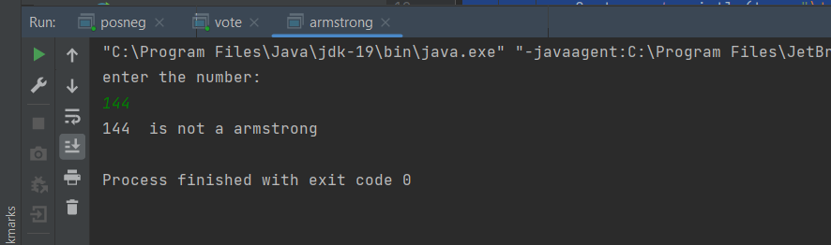

14.Write a java program to check whether a input is palindrome or not.

Program:-

import java.util.*;  
class palindrome  
{  
 public static void main(String[] args)  
 {  
 String original, reverse = "";  
 Scanner in=new Scanner(System.*in*);  
 System.*out*.println("Enter a string/number to check if it is a palindrome");  
 original=in.nextLine();  
 int length=original.length();  
 for( int i=length-1;i>=0;i--)  
 reverse=reverse+original.charAt(i);  
 if (original.equals(reverse))  
 System.*out*.println("Entered string/number is a palindrome.");  
 else  
 System.*out*.println("Entered string/number isn't a palindrome.");  
 }  
}

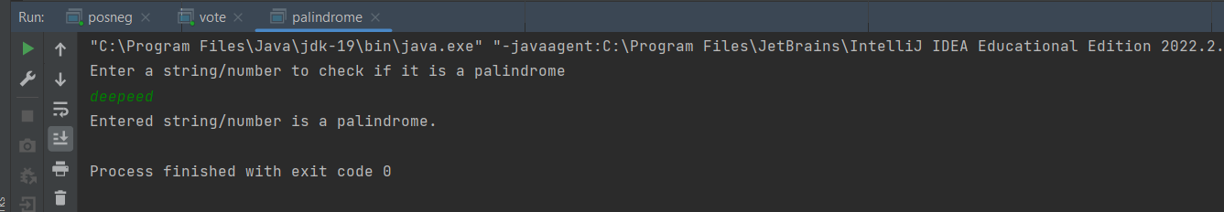

15.Write a java program to reverse a number.

Program:-

import java.util.*;  
class reverser  
{  
 public static void main(String[] args)  
 {  
 int number,reverse = 0;  
 Scanner in=new Scanner(System.*in*);  
 System.*out*.println("Enter a number:");  
 number=in.nextInt();  
 for( ;number != 0; number=number/10)  
 {  
 int remainder = number % 10;  
 reverse = reverse * 10 + remainder;  
 }  
 System.*out*.println("The reverse of the given number is: " + reverse);  
 }  
}

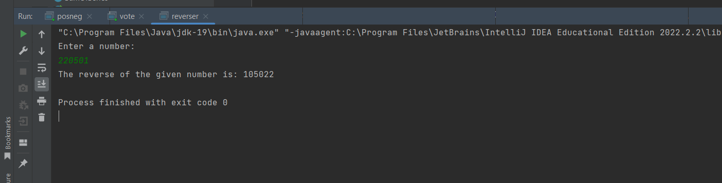

**ASSIGNMENT -1**

16.Write a program to reverse a word using loop? (Not to use inbuilt functions).

Program:-

import java.util.*;  
class as1  
{  
 public static void main(String[] args)  
 {  
 String str,reversedStr = "";  
 Scanner in=new Scanner(System.*in*);  
 System.*out*.println("Enter a string:");  
 str=in.nextLine();  
 for(int i = str.length()-1; i >= 0; i--){  
 reversedStr = reversedStr + str.charAt(i);  
 }  
 System.*out*.println("Original string: " + str);  
 System.*out*.println("Reverse of given string: " + reversedStr);  
 }  
}

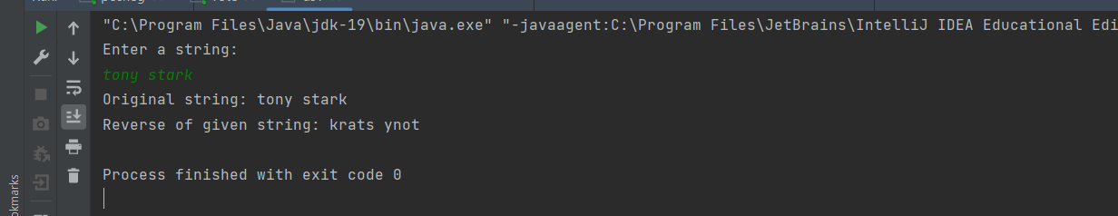

17.Write a program to check whether the entered user name is valid or not. Get both the inputs from the user.

Program:-

mport java.util.*;  
class as2  
{  
 public static void main(String[] args)  
 {  
 String str1,str2;  
 Scanner in=new Scanner(System.*in*);  
 System.*out*.println("Enter user name:");  
 str1=in.nextLine();  
 System.*out*.println("renter user name:");  
 str2=in.nextLine();  
 if (str1.equals(str2))  
 System.*out*.println("user name is valid");  
 else  
 System.*out*.println("invalid user name");  
 }  
}

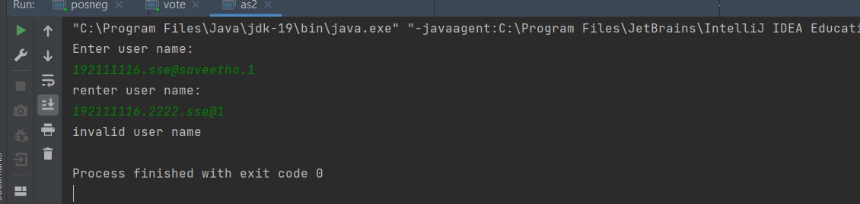

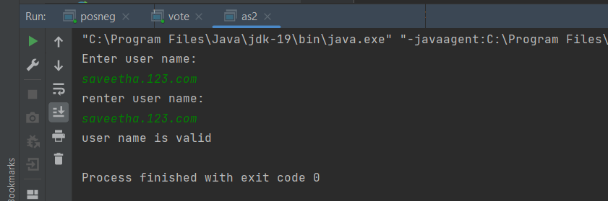

18.Write a program to find whether the person is eligible for vote or not. And if that particular person is not eligible, then print how many years are left to be eligible.

Program:-

import java.util.*;  
class as3vot  
{  
 public static void main(String[] args)  
 {  
 Scanner s=new Scanner(System.*in*);  
 int ag;  
 System.*out*.println(" enter the age of a person:");  
 ag=s.nextInt();  
 if(ag<=0)  
 {  
 System.*out*.println("invalid input");  
 }  
 else if(ag<18)  
 {  
  
 System.*out*.println(" person is not eligible to vote");  
 System.*out*.println(" person is eligible to vote after\t" +(18-ag)+"\t years");  
  
 }  
 else  
 {  
 System.*out*.println(" person is eligible to vote");  
 }  
 }  
}

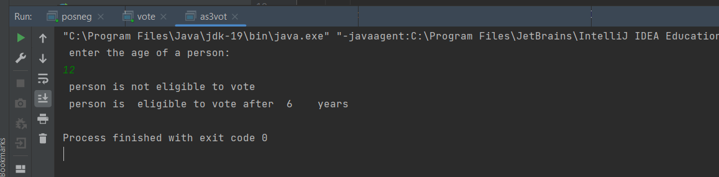

19.Write a program using the function to calculate the simple interest. Suppose the customer is a senior citizen. He is being offered a 12 percent rate of interest; for all other customers, the ROI is 10 percent.

Sample Input:

Enter the principal amount: 200000

Enter the no of years: 3

Is customer senior citizen (y/n): n

Sample Output:

Interest: 60000

Program:-

import java.util.*;  
class as4  
{  
 public static void main(String[] args)  
 {  
 float p,t,si,n;  
 Scanner s=new Scanner(System.*in*);  
 System.*out*.println("enter principle amount:");  
 p=s.nextFloat();  
 System.*out*.println("enter duration in years:");  
 t=s.nextFloat();  
 System.*out*.println("is cu stomer senior citizen (enter '0' for 'yes'/ '1' for 'no')");  
 n=s.nextInt();  
 if(n==0)  
 {  
 System.*out*.println("12% of roi for senior citize");  
 si=(p*t*12)/100;  
 }  
 else  
 {  
 si=(p*t*10)/100;  
 }  
 System.*out*.println("intrest="+si);  
 }  
}

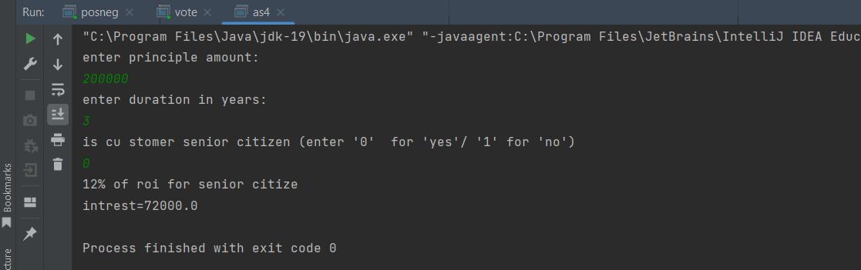

20.Write a Java Program to Convert a Given Number of Days in Terms of Years, Weeks, and Days.

Program:-

import java.util.*;  
class as5  
{  
 public static void main(String args[])  
 {  
 int m, year, week, day;  
 Scanner s = new Scanner(System.*in*);  
 System.*out*.print("Enter the number of days:");  
 m = s.nextInt();  
 if(m<=0)  
 {  
 System.*out*.println("invalid input");  
 }  
 else  
 {  
 year = m / 365;  
 m = m % 365;  
 System.*out*.println("No. of years:" + year);  
 week = m / 7;  
 m = m % 7;  
 System.*out*.println("No. of weeks:" + week);  
 day = m;  
 System.*out*.println("No. of days:" + day);  
 }  
 }  
}

